***Quick Start for using a Statistical PERT® Normal Edition Excel spreadsheet*** 1/2/2020

Using a Statistical PERT® spreadsheet is easy! First, [download the ***Statistical PERT® Normal Edition*** example workbook for Microsoft Excel](https://www.statisticalpert.com/download-free-templates/) , and then use this ***Quick Start*** to understand the basics behind using and modifying your SPERT® spreadsheet.

This Quick Start was created from the [**Version 4.0 Statistical PERT® Normal Edition** example workbook](https://www.statisticalpert.com/download/757/). Statistical PERT spreadsheets follow the same, basic structure and 3-step estimation process:

1. Create a 3-point estimate (minimum, most likely, maximum) for any uncertainty that has bell-shaped (normally distributed) risk properties
2. Render a subjective judgment about *how likely* is the uncertainty’s most likely outcome
3. Select any probabilistic planning estimate, or make a risk-based forecast using SPERT-created estimates

Before you download the ***Statistical PERT® Normal Edition*** example workbook or template from <https://www.statisticalpert.com>, be sure you have Microsoft Excel installed on your computer. You must be running Microsoft Excel 2010, Excel 2013, Excel 2016, Excel 2019 or Office 365. **Statistical PERT is not compatible with Excel Online, Google Sheets, or other spreadsheet software programs**.

Statistical PERT also works on smartphones like the Apple iPhone or any Android-based smartphone – just download the free Microsoft Excel phone app for your iPhone or Android device. Then, either use a full-featured SPERT download on your mobile device, or [download SPERT® Mobile](https://www.statisticalpert.com/download/416/) to use a special, simplified version of Statistical PERT® Normal Edition made especially for the small screen size of mobile devices.

When you first open a downloaded SPERT file from the Internet, the spreadsheet opens to the **Welcome!** tab. Excel may prompt you with a Protected View notice. To use Statistical PERT, you must press the **Enable Editing** button. (You can run your computer’s virus-scanner, firstly, if you wish).

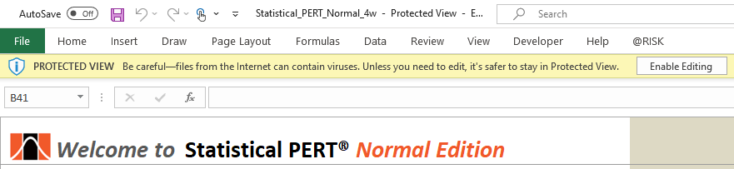

***Important Note for using Statistical PERT® Normal Edition Version 4 (and later)***

Version 4 of Statistical PERT® Normal Edition includes a new worksheet (**SPERT® Normal MC Simulation** tab) that uses Monte Carlo simulation to perform 10,000 trials of a single, random variable. Depending on an application-level setting in your version of Excel, Excel may re-simulate 10,000 trials every time any cell is altered on any worksheet. This action may noticeably slow down the performance of all Statistical PERT worksheets, even those worksheets that do not use Monte Carlo simulation.

To improve the performance of all Statistical PERT® Normal Edition Version 4 (and later) worksheets, change Excel’s formula calculation option to **Automatic Except for Data Tables.** This is an application-level setting—not a file setting—and so you may have to change this setting again if you or another user changes this setting back to **Automatic**.

To make this setting change, do the following:

1. On the Excel Ribbon, identify for the "Calculation" group under the "Formulas" menu selection
2. Click the "Calculation Options" button
3. Select "**Automatic Except for Data Tables**" to increase the speed and calculation performance of all Version 4 SPERT worksheets

Alternatively, if you do not want or need the Monte Carlo simulation worksheet (**SPERT® Normal MC Simulation** tab), you can simply delete this entire worksheet. Deleting the SPERT® Normal MC Simulation worksheet will have no impact to the rest of the worksheets in the Statistical PERT Normal Edition spreadsheet file.

**TL;DR**

On the Excel Ribbon, look for the "Calculation" group under the "Formulas" menu selection. Then, click the "Calculation Options" button and select  
"**Automatic Except for Data Tables**" to increase the speed and calculation performance of all Version 4 Statistical PERT® Normal Edition worksheets.

Or, simply delete the **SPERT® Normal MC Simulation** worksheet from this Excel workbook.

***Using the Super Simple SPERT® worksheet***

The **Super Simple SPERT®**worksheet is the fastest way to learn how Statistical PERT works. To begin, think of an uncertainty that has bell-shaped risk properties. That is, think of an uncertainty that has an improbable minimum value, an improbable maximum value, and a most likely value that lies close to the middle between the minimum and maximum values you chose. Enter your *minimum*, *most likely* and *maximum* values in cells C3:C5, respectively.

In cell C6, see if there is a green checkmark. If so, you’ve correctly entered a 3-point estimate in the right order.

In cell C7, see if the light indicator is green or yellow. If so, your 3-point estimate is indicative of an uncertainty with bell-shaped risk properties.

In cell C9, choose a subjective judgment from the dropdown list that best represents *HOW LIKELY* is the most likely outcome you specified in cell C4. If this is an uncertainty you are very familiar with, you might select “High Confidence” (or something similar), but if this is an uncertainty you are not familiar with, you might choose “Low Confidence” (or something similar). Your choice will influence the implied, bell-shaped probability curve shown in cell C10, and the SPERT probabilistic estimate in cell C16.

Choose a *planning estimate* in cell C12. A *planning estimate* is any value of interest between your minimum and maximum point-estimates. Once you enter a planning estimate, SPERT will calculate (in cells B14, C14 and D14) the probability of the uncertainty’s true value being **equal to** or **less than** your planning estimate, and the probability of the uncertainty’s true value being **greater than** your planning estimate.

Choose any probability between 1% and 99% and enter it in cell C15. SPERT will calculate an estimate in cell C16 that will be **equal to** or **greater than** the uncertainty’s true value with the probability of occurrence you specified in cell C15 *(when “Show Left-Side Area” is chosen in cell C13; if “Show Right-Side Area” is selected in cell C13, then the uncertainty’s true value will exceed the SPERT estimate with the probability of occurrence you specified in cell C15).*

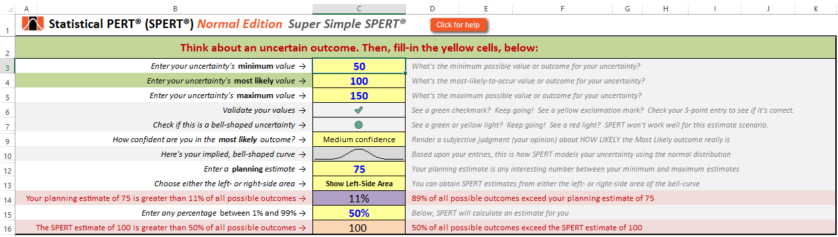

***Using the SPERT® Normal Edition*** *Example Workbook* ***to estimate task duration, expenses, revenue, agile development & more.***

To create probabilistic estimates for bell-shaped uncertainties like task duration, expenses, revenue, agile sprints, event attendance, and more, select:

* **SPERT® Normal for Beginners** to learn how to use Statistical PERT
* **SPERT® Normal (1-Point entry)** to auto-generate three-point estimates using just a **single, one-point estimate** for each uncertainty
* **SPERT® Normal (3-Point entry)** to manually enter **three-point estimates** (minimum, most likely, maximum) for each uncertainty
* **SPERT® Normal (Mixed entry)** to use a mixed approach for creating three-point estimates for each uncertainty
* **SPERT® Normal (Agile Forecast)** to create a release date forecast for agile software development
* **SPERT® Normal (Burnup Chart)** to create an agile burnup chart for agile software development

*Note: This Quick Start uses* ***Version 4.0 of Statistical PERT® Normal Edition****. Statistical PERT example workbooks and templates are occasionally updated, so you may see slight differences between this Quick Start and the SPERT file you are using. However, all Statistical PERT spreadsheets operate similarly, so this Quick Start generally applies to any Statistical PERT® Normal Edition download, Version 2 and higher (not all features are available on older versions of SPERT).*

*If you have downloaded the* ***Statistical PERT® Beta Edition****, you can find the Quick Start for the Beta Edition* [here](https://www.statisticalpert.com/download/755/).

# What’s the Difference between the **Normal Edition** and the **Beta Edition** of Statistical PERT®?

Both editions of Statistical PERT make estimating uncertain outcomes easy using Microsoft Excel.

**Beta Edition:**

* Models a wider range of bell-shaped uncertainties, including very skewed uncertainties, with greater overall accuracy (vs. the Normal Edition)
* Uses ratio scales to estimate the standard deviation and mean
* Uses 290 pre-determined probability curves to fit the best one for a specific uncertainty
* Uses Excel’s BETA.DIST, BETA.INV for the beta distribution (plus NORM.DIST and NORM.INV functions where the Central Limit Theorem applies)
* Cannot be easily changed

**Normal Edition:**

* Models bell-shaped uncertainties where the underlying uncertain only has mild-to-moderate skewing
* Uses simple formulas that can be easily written into a blank Excel spreadsheet
* Is better supported with [whitepapers, brochures, blog articles](https://www.statisticalpert.com/learn-more/), and a [Pluralsight training course](https://www.pluralsight.com/courses/estimate-projects-products)
* Uses Excel’s NORM.DIST, NORM.INV functions for the normal distribution
* Can be easily changed

***Using the SPERT® Normal (1-Point entry) worksheet***

Examine the annotated screenshot below to learn how to enter **single, 1-point estimates** for each uncertainty into the **Statistical PERT® Normal Edition** worksheet, and how to obtain probabilistic estimates for each uncertainty you enter:

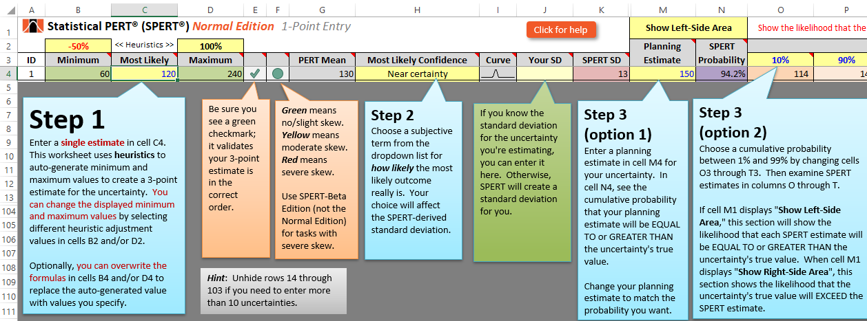

***Using the SPERT® Normal (3-Point entry) worksheet***

Examine the annotated screenshot below to learn how to enter **3-point estimates** for each uncertainty into the **Statistical PERT® Normal Edition** worksheet, and how to obtain probabilistic estimates for each uncertainty you enter:

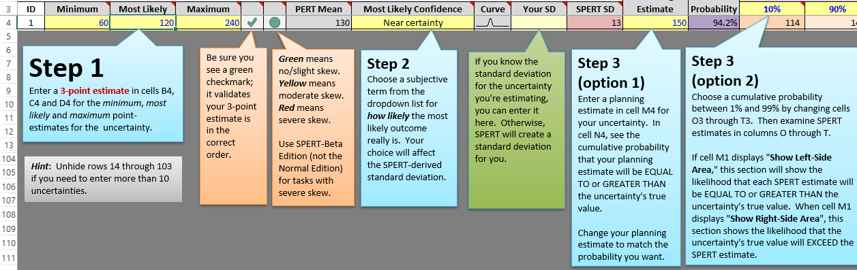

***Using the SPERT® Normal (Mixed entry) worksheet***

This worksheet combines the features of the **1-point entry** and **3-point entry** worksheets into a single worksheet, offering you the flexibility to use global heuristics, row-level calculations, and manual entry of the minimum and/or maximum point-estimates.

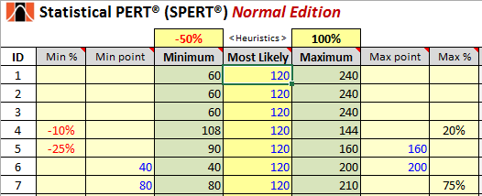

With **Mixed** **entry**, you can choose three different ways to specify the minimum and maximum point-estimates for each uncertainty. You can:

* Use global heuristics (specified above the **Minimum** and **Maximum** column headings) to calculate minimum and maximum point-estimates for all rows as a percentage of the value(s) entered under the **Most Likely** column (just like with the **1-point entry** worksheet)
* Use a row-specific minimum and/or maximum percentage (**Min %** and **Max %**) to calculate minimum and/or maximum point-estimates as a percentage of each row’s **Most Likely** point-estimate
* Enter a minimum and/or maximum point-estimate for any row (under **Min point** and **Max point,** similar to entering values in the **3-point entry** worksheet)

The cell formulas under the **Minimum** and **Maximum** column headings use a precedence order to determine minimum and maximum point-estimates:

* First, if entered, values under the **Min point** and **Max point** are used to create three-point estimates for each uncertainty
* Second, if specified, minimum and/or maximum point-estimates are calculated using the row-specific percentages (these are specified under the **Min %** and **Max %** column headings)
* Third, global heuristics (specified above the **Minimum** and **Maximum** column headings) are used to calculate the minimum and maximum point-estimates for all rows

You can selectively choose when to use global heuristics, row-level percentages, or specific values for the minimum and maximum point-estimates.

On the bottom half of the **SPERT® Normal (1-Point entry)**, **SPERT® Normal (3-Point entry)**, and **SPERT® Normal (Mixed entry)** worksheets, you will see probabilistic estimates for all the uncertainties you entered, respectively, in those worksheets. You may change any of the cells highlighted with a bright yellow background color. The other cells have formulas in them; do not change those cells.

Use this section to create a range forecast showing the likelihood of all uncertainties having a sum between the lowerbound and upperbound limits.

***Example using work effort estimates for all tasks on a project*** *{SPERT® Normal (1-Point entry) worksheet}:*

* Enter all work effort estimates for all project tasks (using effort hours, days, weeks, story points, etc.) in rows 4 through 103
* Create a high confidence range forecast for the project by entering a high confidence percentage (like 80% or higher) in cell D108, then see how much total effort the entire project will likely require in cells D109 and D110
* Choose a custom interval by specifying both the lowerbound and upperbound limits in cells D112 and D113, respectively, then examine the likelihood that the project’s total effort will be within the interval you specified

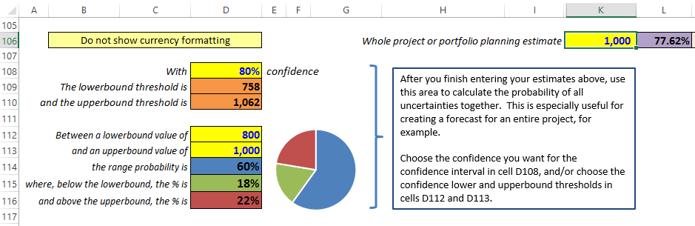

***Using the SPERT® Normal Charts worksheet***

On this worksheet, you can model just one uncertainty and see the implied, bell-shaped probability curve (the probability density function):

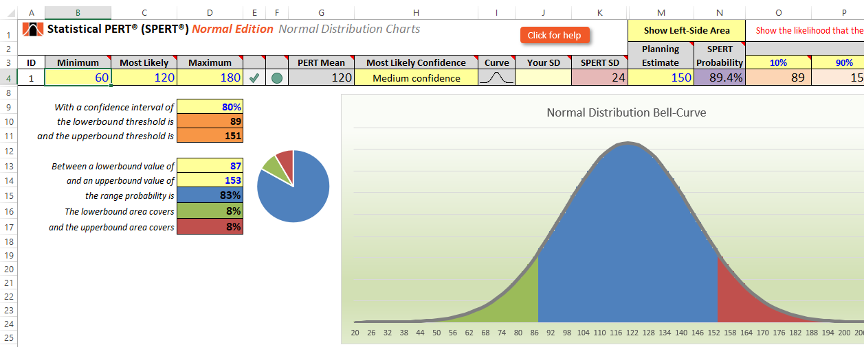

Changing *minimum, most likely* and/or *maximum* values (cells B4, C4, and D4, respectively) or changing the *most likely confidence* dropdown (cell H4) will alter the appearance of the tri-colored, bell-shaped curve. The areas under the bell-curve are determined by the values in cells D13 and D14, which determine the lowerbound and upperbound thresholds, respectively.

***Using the SPERT® Normal MC Simulation worksheet***

On this worksheet, you can model just one random, independent variable **using Monte Carlo simulation** and see the implied, bell-shaped probability curve (the probability density function):

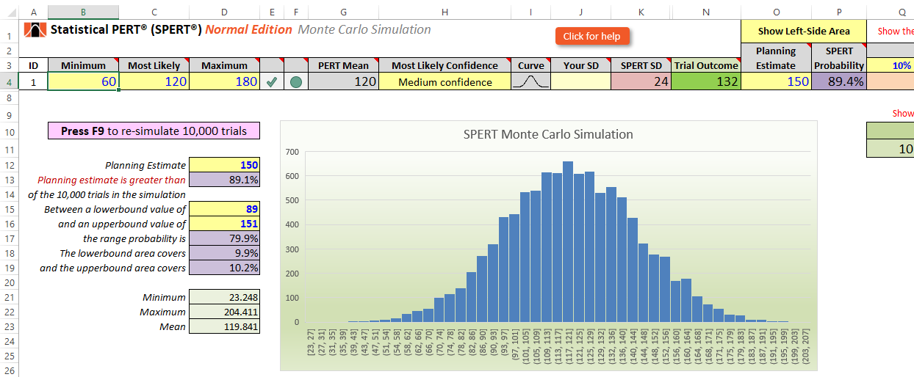

The Monte Carlo simulation uses an Excel data table to sample 10,000 trials of the uncertainty with the characteristics you specified (that this, your 3-point estimate and your *Most Likely Confidence* dropdown selection). To re-simulate, **press F9**. If the Statistical PERT spreadsheet appears sluggish on other worksheets, check the Excel formula calculation setting for Excel. This is an application-level setting.

Here’s how to do that: on the Excel Ribbon, look for the "Calculation" group under the "Formulas" menu selection. Then, click the "Calculation Options" button and select "**Automatic Except for Data Tables**" to increase the speed and calculation performance of all Version 4 SPERT worksheets. Or you can simply delete the SPERT® Normal MC Simulation worksheet from this Excel workbook of you don’t want or need to use the Monte Carlo simulation capability of Statistical PERT.

***Using the SPERT® Agile Forecast worksheet***

On this worksheet, you can evaluate different release date options for your agile team using Scrum or for a team that uses regular iteration cycles to plan work:

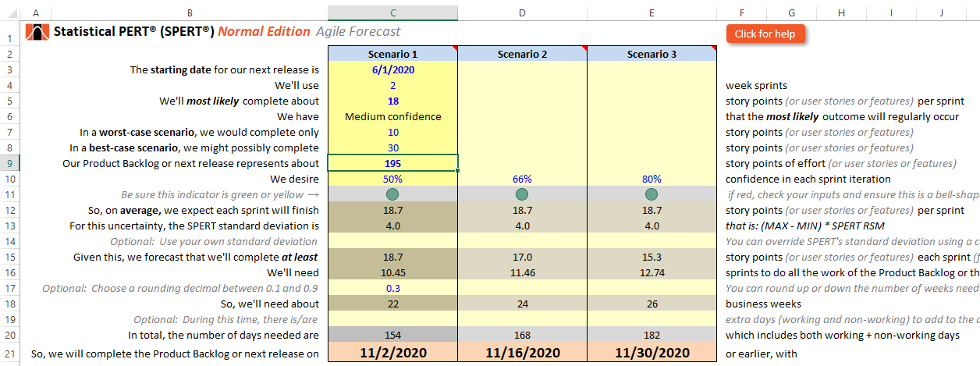

This worksheet uses the same approach for estimating as all SPERT worksheets: Enter a 3-point estimate (cells C5, C7 and C8) and a subjective judgment about the most likely outcome in the C6 dropdown. Use your team’s velocity (actual or estimated) in cell C5. Enter the total work represented on your product backlog or the next major release in cell C9. Statistical PERT will generate a standard deviation which is necessary to make a probabilistic date calculation. For higher confidence, the release date will be longer, with less confidence, the release date will be sooner. *Be very cautious about selecting any release date with less than 50% confidence (cell C10), as very often “unknown unknowns” in software development causes work efforts to take longer than expected!*

Use the optional rounding decimal (cell C17) to force fractional sprints to be rounded up. In the example above, cell C16 shows it takes 10.45 sprints to complete 195 units of work represented on the product backlog, but that is rounded up to 11 sprints (22 business weeks in cell C18; each sprint is 2 weeks long in the example) by adding an extra 0.3 amount to force rounding up to the next integer amount.

Scenarios 2 and 3 (columns D and E) use the same inputs as Scenario 1 unless they are explicitly overridden. In the example above, Scenario 2 replaces the 50% confidence choice in cell C10 with a 66% value in cell D10, and Scenario 3 uses an 80% value in cell E10. Scenario 1’s other input choices remain unchanged.

***Using the SPERT® Agile Burnup worksheet***

On this worksheet, you can enter input values necessary to create an agile burnup chart. The agile burnup chart plots the amount of work your agile team has completed so far, and then estimates the most likely amount of work your team will complete in the future, along with two other projections (usually, an optimistic/aggressive estimate and a pessimistic/conservative estimate):

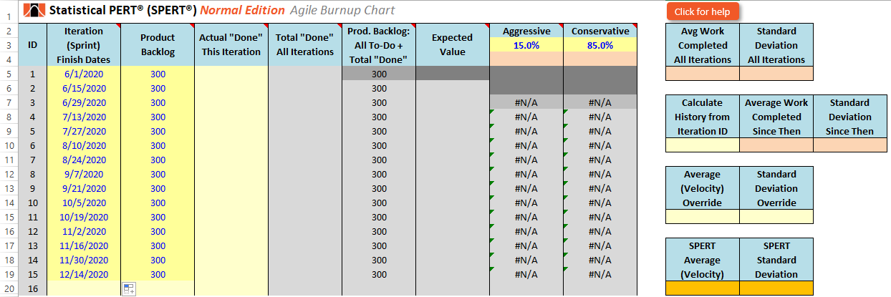

First, enter the iteration finish dates *for at least six iterations* in cells B5:B10. You can enter up to 52 iteration finish dates by unhiding rows 21 to 56. Then, enter the total amount of work to be completed in cell C5 (either the entire product backlog, or a subset of the product backlog for release planning). Drag down the value in cell C5 to match the number of iteration finish dates you entered.

In the example above, there are 15 iteration finish dates, so the cell value in C5 is copied downward to cells C6:C19.

Then, as your team completes an iteration, fill-in column D with the amount of “done” work that your team completed. Adjust the amount of work left to do in column C to reflect product backlog changes (work that is removed, work that is added, work that is completed), and re-copy downward in column C the work left to complete. *Do not go back to change the history of what was formerly estimated on the Product Backlog!* The historical account will be reflected in the Product Backlog trend line on the agile burnup chart.

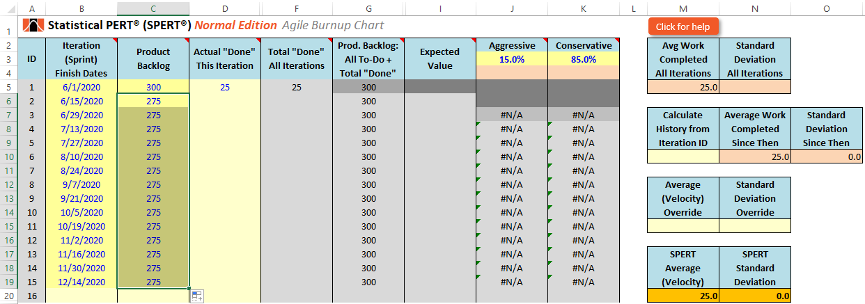

In the example above, after the 6/1/2020 iteration completed, a Scrum team completed 25 story points off their product backlog (cell D5). The new amount of work left to complete is 275 story points (300 minus the 25 that was finished in the first iteration). So, 275 is entered in cell C6 and copied downward to cell C19 to match the last iteration finish date. *Note that the number of story points estimated in cell C5 is left unchanged after the first sprint finishes.*

***Important note***: Always re-calculate the amount of work left to complete on the Product Backlog (or for the next release) at the end of every iteration. The amount may change because new items might be added, and existing items might have been removed or re-estimated. Product Backlogs are actively managed and the amount of work left to do may change frequently throughout the iteration.

Once you have finished several iterations and have added the history of what each iteration completed, you’ll begin to see how the agile burnup chart shows both the historical record and a projection of what the team might accomplish in future iterations.

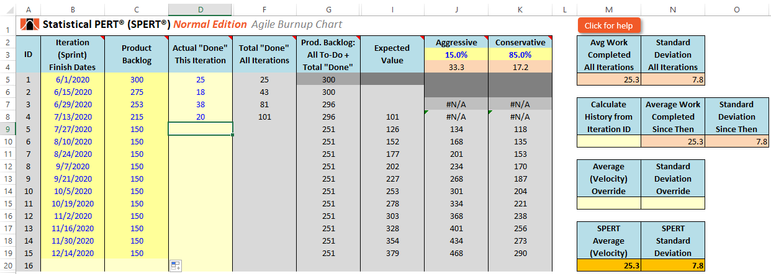

In the example above, a Scrum team has worked together for four sprints. They have completed 101 story points of work to-date (cell F8). After the 4th sprint, the Product Owner removed items from off the Product Backlog to shorten the delivery date, leaving only 150 story points left to do. The aggressive finish date (only 15% probable) is 9/21/2020. The expected finish date (only 50% probable) is 10/5/2020. The conservative finish date (85% probable) is 11/16/2020.

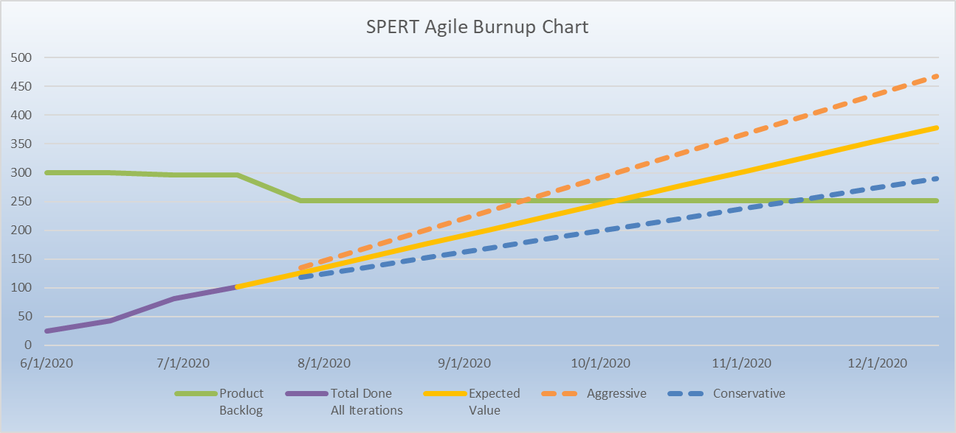

***Using the VLookups worksheet***

On this worksheet, you can manipulate the SPERT **Ratio Scale Modifier (RSM)** values, and add/modify/delete subjective terms used to describe how likely the most likely outcome really is. You can modify other lookup tables used throughout the Statistical PERT spreadsheet.

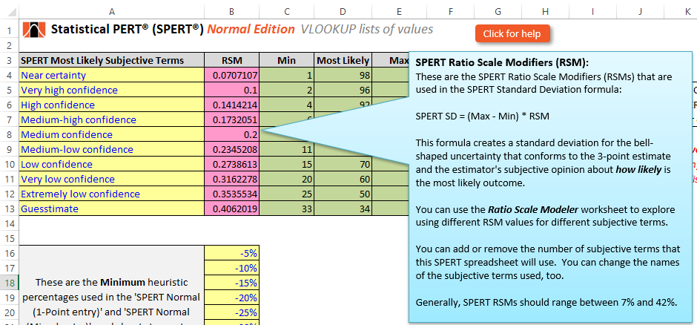

***Using the Ratio Scale Modeler worksheet***

On this worksheet, learn how Statistical PERT creates Ratio Scale Modifiers to create standard deviations used in many formulas in the spreadsheet.

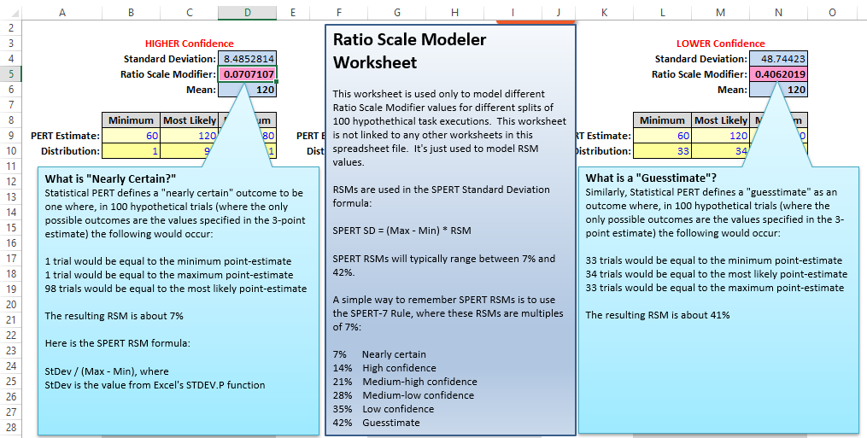

***Get More Information on Statistical PERT®***

There are many ways to get more information about Statistical PERT. Visit the Statistical PERT website at <https://www.statisticalpert.com> and click on the [Learn More](https://www.statisticalpert.com/learn-more/) tab to get more information about Statistical PERT. Also, click on the [News & Blog](https://www.statisticalpert.com/news-blog/) tab to get access to blogs and new information about Statistical PERT.

***Have any Questions? Find a Bug? Want to Connect?***

Email: [famousdavispmp@gmail.com](mailto:famousdavispmp@gmail.com)

LinkedIn: <https://www.linkedin.com/in/famousdavis>

Twitter: <https://twitter.com/StatisticalPERT>

YouTube: <https://www.youtube.com/StatisticalPERT/>

